Practice task 4 REPORT

«Active band-pass filter circuit design and simulation»

**Principles of Circuits**

Student:

Program of Automation

group AT

Name Surname：Li Xin

# Work purpose: to study parameters of Active Band-pass Filters

Goals:

1) Design an active band-pass filter on the basis of operational amplifier «Opamp_name»

2) Choose capacitors

2) Simulate frequency domain of the filter and determine middle frequency, gain corresponding to the middle frequency and bandwidth

3) Compare results of simulation of the real operational amplifier and the ideal operational amplifier



# Starting data

* **Amplifier scheme : Sallen-Key or Multiple Feedback**
* **Filter type: Band-pass**
* **Required gain of amplifier $K=$** -1
* **Operational Amplifier :**
* **Voltage source power supply** Vcc $=6$ (V) / Vee $=−6$ (V)
* **Middle frequency of bandpass: $f_{0}=2000$**  (Hz)
* **Test signal voltage magnitude $V_{test_{AC}}=V_{test}=2$** (V)
* **Resistor parameters**

$R_{1}=1850$ (Ω)

$R_{2}=3700$ (Ω)

$R_{3}=1850$ (Ω)

$R_{Load}=$ 1 000 000 (Ω)

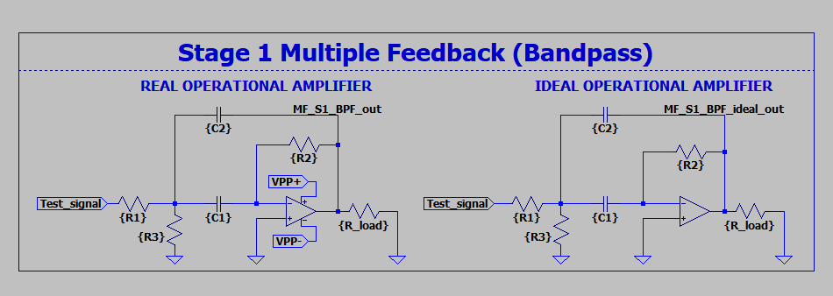

Figure 1 – multiple Band-Pass filter

# Calculations

## Calculate $C_{1}$ and $C_{2}$ according to the formula for the middle frequency $f_{0}$ corresponding to your filter type ( Multiple Feedback):

$C_{1}=C_{2}=$ 43.015 [µF]

# Simulation results

## Define bandwidth $B$, $f_{0}$ as a middle of bandwidth and signal gain corresponding to the middle frequency $K_{ω_{0}}$:

* **For the ideal operational amplifier**

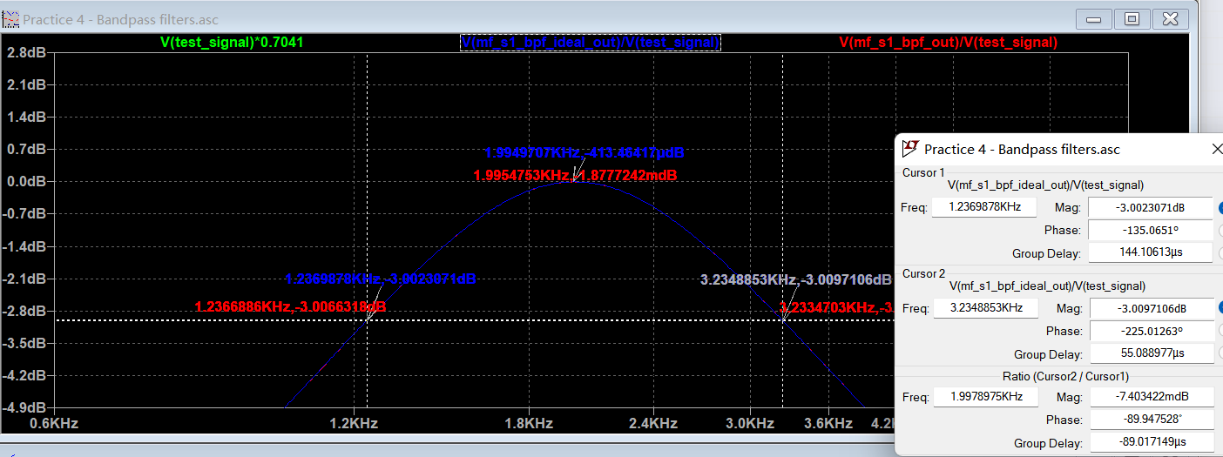

Fig. 2 – Bandwidth, middle frequency and gain corresponding to the middle frequency of the band-pass filter with the ideal operational amplifier

$B_{ideal}=$***1997.8975***

$$f_{0_ideal}=1994.9707 [Hz]$$

$K_{ω_{0}_ideal}=$**-0.41346**

* **For the real operational amplifier**

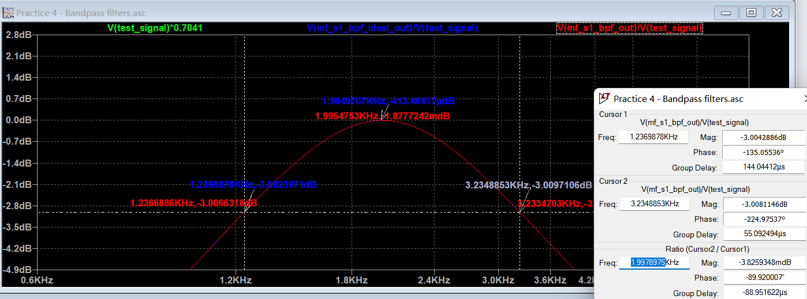

Fig. 3 – Bandwidth, middle frequency and gain corresponding to the middle frequency of the band-pass filter with the real operational amplifier

$B_{real}=$***1997.8975***

$$f_{0_real}= 1995.4753 [Hz]$$

$K_{ω_{0}_real}=$**-0.001877**

# Conclusions

Conclusions should contain:

1. Values of $f_{0_real}$, $f_{0_ideal}$

$f_{0_real}$ = $1995.4753$

$f_{0_ideal}$ = $1994.9707$

1. Values of $B_{ideal}$, $B_{real}$

$B_{ideal}=$ 1997.8975

$B_{real}=$ 1997.8975

1. Values of $K_{ω_{0}_ideal}, K_{ω_{0}_real}$

$K_{ω_{0}_ideal}=$-0.41346

$K_{ω_{0}_real}=$-0.001877